Sri Lanka Institute of Information

Technology



Lab Submission

<Lab sheet No 05>

**<IT24100818>**

**<Pabasara H. E. T.>**

**Probability and Statistics | IT2120**

B.Sc. (Hons) in Information Technology

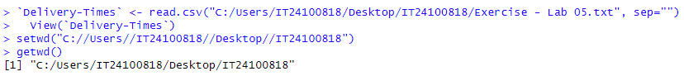

1. Import the dataset (’Exercise – Lab 05.txt’) into R and store it in a data frame called” Delivery Times”.

2. Draw a histogram for deliver times using nine class intervals where the lower limit is 20 and upper limit is 70. Use right open intervals.

3. Comment on the shape of the distribution.

The distribution of delivery times is roughly symmetric, centered around 40 minutes. Frequencies rise towards the middle (30 -45 minutes), then fall off towards the ends (20 – 25 minutes and 65 – 70 minutes). There is no extreme skewness and the highest frequency (the “peak”) is around the 35 -45 minute interval.

4. Draw a cumulative frequency polygon (ogive) for the data in a separate plot.  
